Assignment 18.1

Loading datasets in to variable:

S18_Dataset_Transport

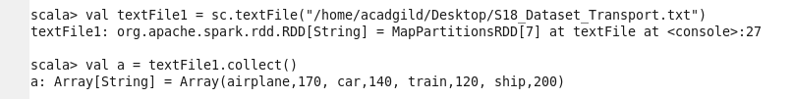

S18_Dataset_User_details

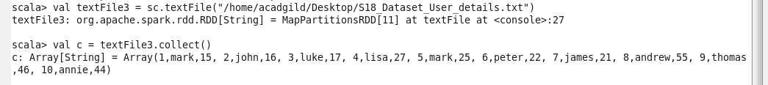

S18_Dataset_Holidays

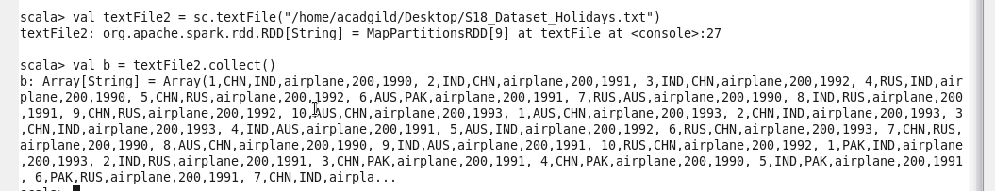

Problem Statement 1:

What is the distribution of the total number of air-travelers per year:

